 | 16 Editors - Dope Sheet
Table of content
The Dopesheet Editor 2
Time cursor 2
Keyframe types 2
Markers 3
Recording 3
Viewport Navigation 4
Viewport navigation 4
Channel Context Menu 4
Frame selected channels 4
Mute Channel 4
Unmute Channel 4
Protect Channels 5
Unprotect Channels 5
Group Channels 5
Ungroup Channels 5
Toggle Channel Editability 5
Extrapolation Mode submenu 5
Extrapolation Mode 5
Constant Extrapolation 5
Linear Extrapolation 5
Make Cyclic 5
Clear Cyclic 5
Expand Channels 5
Collapse Channels 5
Move submenu 6
Delete Channels 6
Dope Sheet Context Menu 6
Copy 6
Paste 6
Paste Flipped 6
Keyframe Type 6
Handle Type 6
Interpolation Mode 7
Easing Mode 7
Insert Keyframes 7
Duplicate 7
Delete Keyframes 7
Delete Breakdowns 7
Delete Duplicate Frames 7
Mirror 7
Snap 7
Slider snapping 8
Quick Favorites menu 8

The Dopesheet Editor

The Dopesheet Editor is the editor type to edit the keyframe data of your animation data. The Dopesheet editor is part of five editor types that deals with your animation data. It is some kind of a chart, and gives you an overview over all of your animation data.

The Dope sheet editor has several areas.
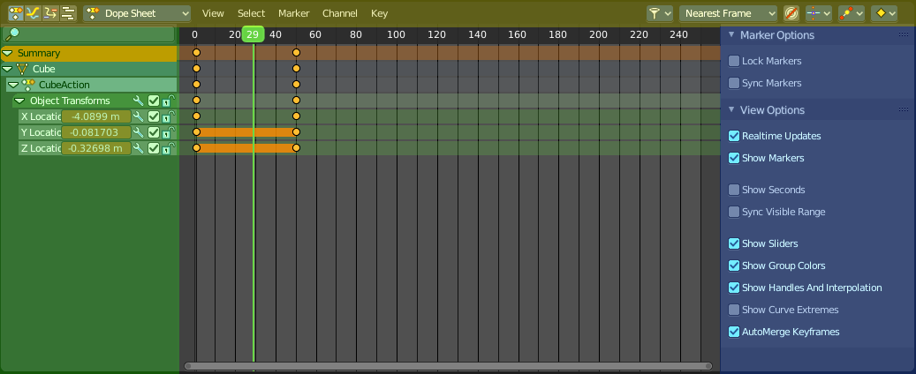
Header ( Yellow )
Channel list ( Green )
Sidebar ( Blue )
Viewport ( no color )
The header is divided into two parts too. Left tools and menus. Right Options.

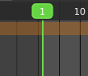
Time cursor
The Time Cursor is the green line. It is used to set and display the current time frame.

Keyframe types
The keyframes can have different color and shape.
Gray - Unselected keyframe.
Yellow - Selected keyframe.
Diamond - Free keyframe handle.
Round - Auto Clamped keyframe handle.
Circle - Automatic Keyframe handle.
Square - Vector Keyframe handle.
Rhombus - Aligned Keyframe handle.
Various colors - You can give keyframes an own color with the keyframe type drop down menu at the right.
Gray bar between keys - The two keyframes are identical.
Green line between keys - Fixed keyframe interpolation.
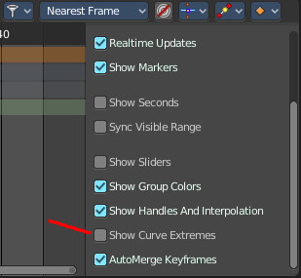
Upwards arrow - Maximum Extreme keyframe. You need to enable Show Curve extremes in the Marker options in the sidebar.
Downwards arrow - Minimum Extreme keyframe. You need to enable Show Curve extremes in the Marker options in the sidebar.

Markers
Markers are visible hints to denote frames with key points or significant events within an animation. A marker could mark a character’s animation starts, the position change of a camera, or a door that opens.
Markers can be added, deleted and renamed from the Marker menu. Once created they reside at the bottom of the viewport.
To select a marker click at it.
To move a marker click and drag.
The active marker is highlighted, and shows a dotted line upwards.
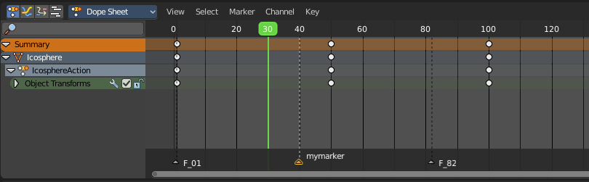

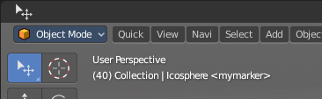
When a frame matches the marker position then the info string in the 3D view shows the name of this marker too.

Recording
You usually set and record the keyframes in the 3D view. Or by activating the decorators besides a menu item in a panel.
The Dope Sheet Editor also allows you to record keyframes. Have a look in the Key menu for Insert Keyframes.
There is an exception. The grease pencil object. This is because it can have two types of keyframes. One in object mode. For the whole object. And one in edit mode. For animating points of the curve geometry. This is what the Grease Pencil mode belongs to.
In Grease Pencil mode the changes at the geometry are recorded automatically by modifying the current geometry at the current frame. There is no extra Insert Keyframes menu item. The keyframes gets generated when you modify the geometry.

Viewport Navigation

Navigation in the viewport happens by mouse or hotkeys. Some of them does not have a menu entry. And needs to be explained here.

Viewport navigation
Right mouse button moves the frame marker.
Clicking left at the number bar moves the frame marker.
Middle mouse button pans the view.
Holding ctrl + middle mouse button zooms the view.
Scroll Wheel zooms the view.
To drag a keyframe click at it and drag the mouse.

Channel Context Menu

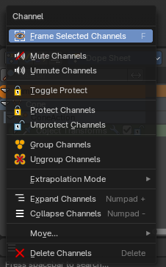
When you right click into the channel area, then you will call the Channel context menu.

Frame selected channels
Centers the selected channels in view.

Mute Channel
This channel is not calculated.

Unmute Channel
This channel is calculated.

Protect Channels
Protect channels from editing.

Unprotect Channels
Enables editing of channels again.

Group Channels
Groups channels together.

Ungroup Channels
Ungroup grouped channels. Beware, the channels will not return to their initial group.

Toggle Channel Editability
Protects or unprotects the selected channels.

Extrapolation Mode submenu

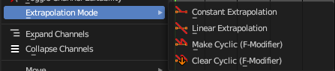
Extrapolation Mode
Sets the extrapolation mode for the selected F-Curves. Means how the curve acts at the beginning and the end of the F-Curve.

Constant Extrapolation
The animation curve continues straight at the end.

Linear Extrapolation
The animation curve continues the last direction.

Make Cyclic
Makes the animation loopable. The interpolation curves are adjusted so that the first frame fits to the last frame.

Clear Cyclic
Removes the cyclic extrapolation.

Expand Channels
Expands the channels.

Collapse Channels
Collapses the channels.

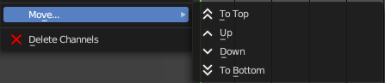
Move submenu
Sort the order of the channels. The menu items should be self explaining.

Delete Channels
Removes the selected channels.

Dope Sheet Context Menu
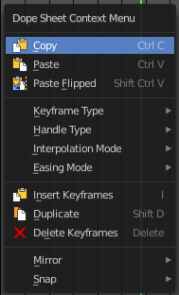
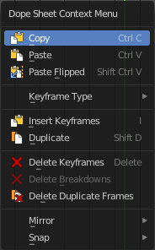
When you right click into the dope sheet viewport then you will call the Dope Sheet context menu.

Copy
Copies the currently selected keyframe(s).

Paste
Pastes copied keyframe(s).

Paste Flipped
Pastes copied keyframe(s), but flipped.

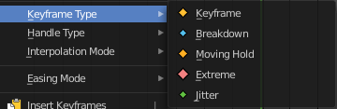
Keyframe Type
Recolor the currently selected keyframes.

Handle Type
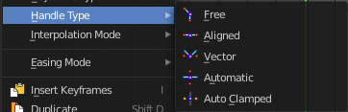
Set the handle type for the currently selected keyframes.
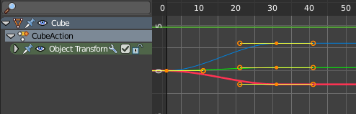
This is a feature for the Graph editor, where each curve point has its own handler with which you can influence the curve behavior. But the handler type also influences how the animation curve acts at the chosen keyframes. So it has its use in the dope sheet editor too.

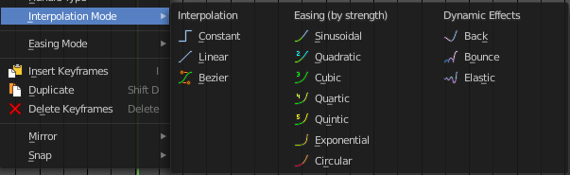
Interpolation Mode
The Interpolation mode defines how the curve acts from keyframe to keyframe. You can have a linear curve between two keyframes instead of a bent one for example.
The easing methods here in the interpolation mode menu are for the easing shape. There is also an easing menu where you can choose a easing method.

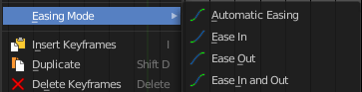
Easing Mode
Choose a easing method. The easing methods in the interpolation mode menu are for the easing shape.

Insert Keyframes
Insert a keyframe at the current position.

Duplicate
Duplicate the selected keyframe(s).

Delete Keyframes
Delete the selected keyframe(s).

Delete Breakdowns
In Grease Pencil mode. Deletes breakdown poses generated by interpolating between two grease pencil frames.

Delete Duplicate Frames
In Grease Pencil mode. Deletes all duplicated frames.

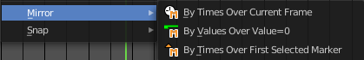
Mirror
Mirrors the animation by the given method.

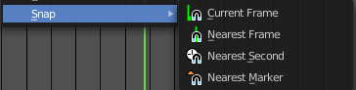
Snap
Snaps the selected keyframes by the given method.

Slider snapping
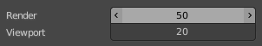
Snapping also works at sliders. Hover with the mouse over the slider, start to slide, and holding down Ctrl will snap the sliders in incremental steps.
When it's a default value between 0 and 1 then it usually snaps in 0.1 steps. When it's a default value over 1 then it usually snaps in steps of 10.
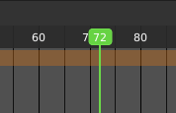
The increment snapping also works at the frame slider. Here the incremental snapping happens by the frame rate that you have defined. With a frame rate of 24 it will snap in steps of 24 frames when holding down ctrl.

Quick Favorites menu


When you right click at a menu or a button, then a right click menu will open. Tools have usually a Add to Quick Favorites menu entry.
The Quick Menu is empty by default. With Add to Quick favorites you can add this menu to the Quick menu.

In the 3D view we have a menu called Quick in the header, which shows this content then. In the Dope Sheet Editor you can just call it with its hotkey. Q. It has no regular menu entry here.

